DEVIKA.B
ROLL NO:22
Experiment 15

File Operations in Java

AIM:

Write a program that performs various file operations such as reading, writing, and
appending data to a file.

SOURCE CODE:

import java.io.*;
import java.util.Scanner;

public class FileOperations {
public static void main(String[] args) {
Scanner scanner = new Scanner(System.in);
String filename = "sample.txt";

while (true) {
System.out.println("\nFile Operations Menu:");
System.out.println("1. Write to File");
System.out.println("2. Read from File");
System.out.println("3. Append to File");
System.out.println("4. Exit");
System.out.print("Choose an option: ");

int choice = scanner.nextInt();
scanner.nextLine(); // Consume newline

switch (choice) {
case 1:
writeToFile(filename, scanner);
break;
case 2:
readFromFile(filename);
break;
case 3:
appendToFile(filename, scanner);
break;
case 4:
System.out.println("Exiting program...");
scanner.close();
return;
default:
System.out.println("Invalid choice! Try again.");
}
}
}

// Method to write to file
public static void writeToFile(String filename, Scanner scanner) {
try (BufferedWriter writer = new BufferedWriter(new FileWriter(filename))) {
System.out.print("Enter text to write to file: ");
String content = scanner.nextLine();
writer.write(content);
writer.newLine();
System.out.println("Data written to file successfully.");
} catch (IOException e) {
System.out.println("Error writing to file: " + e.getMessage());
}
}

// Method to read from file
public static void readFromFile(String filename) {
try (BufferedReader reader = new BufferedReader(new FileReader(filename))) {
String line;
System.out.println("\nContents of the file:");
while ((line = reader.readLine()) != null) {
System.out.println(line);
}
} catch (IOException e) {
System.out.println("Error reading file: " + e.getMessage());
}
}

// Method to append to file
public static void appendToFile(String filename, Scanner scanner) {
try (BufferedWriter writer = new BufferedWriter(new FileWriter(filename, true))) {
System.out.print("Enter text to append to file: ");
String content = scanner.nextLine();
writer.write(content);
writer.newLine();
System.out.println("Data appended to file successfully.");
} catch (IOException e) {
System.out.println("Error appending to file: " + e.getMessage());
}
}
}

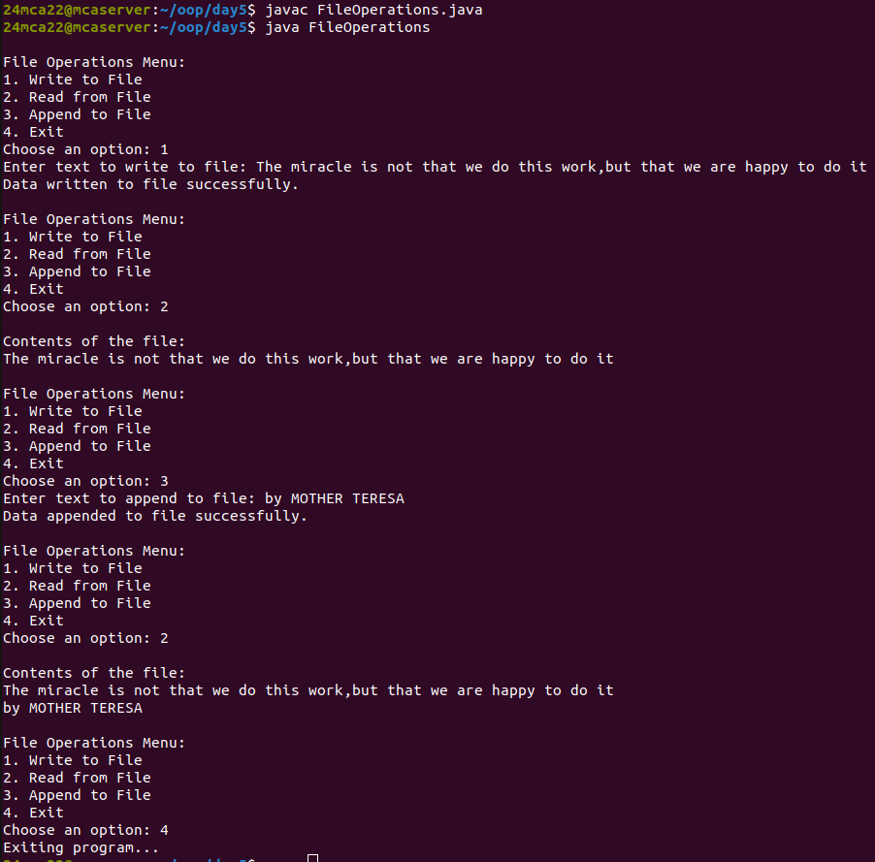
OUTPUT

Experiment 16

System-Defined and User-Defined Exception for Authentication

AIM

Write a Java program that demonstrates both system-defined exceptions (such as FileNot-
FoundException and IOException) and user-defined exceptions for authentication fail-
ures. Implement a readFile(String filename) method that attempts to read a file and
prints its contents while handling FileNotFoundException if the file does not exist and
IOException for other input/output errors. Define a custom exception class AuthenticationException that extends Exception and create an authenticate(String username, String
password) method to validate user credentials against predefined values (e.g., ”admin”
with password ”admin123”), throwing an AuthenticationException if authentication fails.
In the main method, prompt the user to enter a filename, attempt to read the file, then
request login credentials, invoking authenticate() and handling exceptions using try-catch
blocks to display appropriate error messages, ensuring meaningful feedback to the user.

SOURCE CODE:

import java.io.*;
import java.util.Scanner;

// Custom Exception for Authentication Failure
class AuthenticationException extends Exception {
public AuthenticationException(String message) {
super(message);
}
}

public class AuthenticationSystem {
public static void main(String[] args) {
Scanner scanner = new Scanner(System.in);

// Step 1: File Handling
System.out.print("Enter filename to read: ");
String filename = scanner.nextLine();
readFile(filename);

// Step 2: Authentication
System.out.print("\nEnter username: ");
String username = scanner.nextLine();
System.out.print("Enter password: ");
String password = scanner.nextLine();

try {
authenticate(username, password);
System.out.println("Authentication successful! Welcome, " + username + ".");
} catch (AuthenticationException e) {
System.out.println("Authentication failed: " + e.getMessage());
}

scanner.close();
}

// Method to read a file and handle exceptions
public static void readFile(String filename) {
try (BufferedReader reader = new BufferedReader(new FileReader(filename))) {
System.out.println("\nContents of " + filename + ":");
String line;
while ((line = reader.readLine()) != null) {
System.out.println(line);
}
} catch (FileNotFoundException e) {
System.out.println("Error: File not found - " + filename);
} catch (IOException e) {
System.out.println("Error reading file: " + e.getMessage());
}
}

// Method to authenticate user
public static void authenticate(String username, String password) throws AuthenticationException {
String correctUsername = "admin";
String correctPassword = "admin123";

if (!username.equals(correctUsername) || !password.equals(correctPassword)) {
throw new AuthenticationException("Invalid username or password.");
}
}
}

OUTPUT
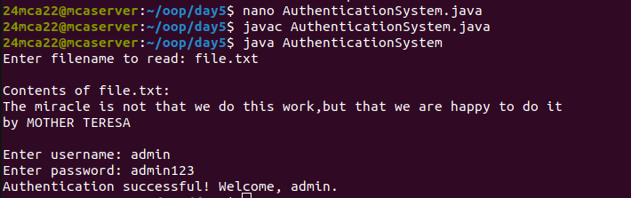

Experiment 17

Multithreading

AIM:

Write a Java program that defines two classes: one for generating and displaying the mul-
tiplication table of 5 and another for printing the first N prime numbers. Implement both
classes using multithreading, demonstrating both approaches—by extending the Thread
class and implementing the Runnable interface. Ensure proper thread management and
synchronization if needed.

SOURCE CODE:

import java.util.Scanner;

// Thread using "extends Thread" for multiplication table of 5
class MultiplicationTable extends Thread {
public void run() {
System.out.println("\nMultiplication Table of 5:");
for (int i = 1; i <= 10; i++) {
System.out.println("5 x " + i + " = " + (5 * i));
try {
Thread.sleep(500); // Sleep for 500ms to simulate processing
} catch (InterruptedException e) {
System.out.println("Multiplication thread interrupted.");
}
}
}
}

// Thread using "implements Runnable" for generating prime numbers
class PrimeNumbers implements Runnable {
private int count;

PrimeNumbers(int count) {
this.count = count;
}

public void run() {
System.out.println("\nFirst " + count + " Prime Numbers:");
int num = 2, primeCount = 0;
while (primeCount < count) {
if (isPrime(num)) {
System.out.print(num + " ");
primeCount++;
try {
Thread.sleep(300); // Sleep for 300ms to simulate processing
} catch (InterruptedException e) {
System.out.println("Prime thread interrupted.");
}
}
num++;
}
System.out.println();
}

private boolean isPrime(int num) {
if (num < 2) return false;
for (int i = 2; i * i <= num; i++) {
if (num % i == 0) return false;
}
return true;
}
}

// Main class to start both threads
public class MultiThreadingExample {
public static void main(String[] args) {
Scanner scanner = new Scanner(System.in);

// Getting user input for prime numbers
System.out.print("Enter the number of prime numbers to generate: ");
int n = scanner.nextInt();

// Creating thread objects
MultiplicationTable tableThread = new MultiplicationTable();
Thread primeThread = new Thread(new PrimeNumbers(n));

// Starting both threads
tableThread.start();
primeThread.start();

// Ensuring both threads complete execution before continuing
try {
tableThread.join();
primeThread.join();
} catch (InterruptedException e) {
System.out.println("Main thread interrupted.");
}

System.out.println("\nBoth threads have finished execution.");
scanner.close();
}
}

OUTPUT
